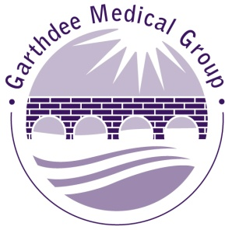
DR SUSAN SHPEHERoCTN

PARTNER

ANNOUNCEMENT

RETIREMENT / NEW PARTNER

DR GAIL DAVIDSON – RETIREMENT

Garthdee Medical Group would like to announce the retirement of

Dr Gail Davidson.

Dr Davidson has been a Partner at Garthdee Medical Group for over 25 years and will be remembered for her unconditional dedication, hard work and commitment to the patients of Garthdee. She also enjoyed being a Trainer to the GP Registrars over the last 15 years.

We hope you join us in wishing her the very best in her new ventures in the future.

DR DAKSHA BHADRASHETTY - NEW GP PARTNER
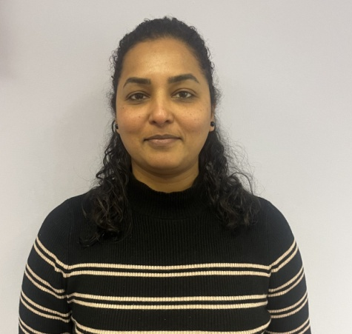
We are also very pleased to announce that Dr Daksha Bhadrashetty will be joining Garthdee Medical Group as a new Partner from 1st April 2024. We wish her the very best and offer her our congratulations in her new role.
We hope you join us in welcoming her to Garthdee Medical Group.

